**Microprocessor Lab**

Laboratory Activity No. 1

**Familiarization with TinkerCAD**

|  |
| --- |
|  |

Score

*Submitted by:*

**Muro, Cyron Paul T.**

**SAT 1-4 pm / CPE 0412.1-2**

*Date Submitted*

**09-16-2023**

*Submitted to:*

**Engr. Maria Rizette H. Sayo**

1. Exercise

a. A process in Tinkercad where we can develop electronic circuits that can be quickly updated, modified and tested is called _____Prototyping________.

b. In Tinkercad, ______Simulation_____ tests the working of the circuits and the components.

c. The device used to assemble and connect the various components is known as __Breadboard________

d. In an electronic circuit with LED, the positive end of the circuit should be connected to

__Anode___ and negative end should be connected to _____Cathode______ of the LED.

e. A _______Resistor_________ is used to restrict the flow of current to electrical components

2. Label the following:

1. Anode and Cathode in a LED



Cathode Anode

1. Different parts of breadboard

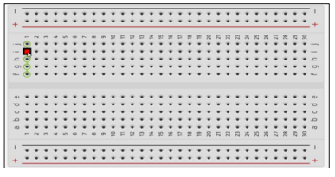

**EDGE Main Area**

1. List the electronic components used in a circuit assembly

* Resistors
* Capacitors
* Diodes
* Transistors
* Connectors
* Power Supply